Examining Depreciation and Wealth Concentration Through Agent-Based Modeling

Bryant University Honors Program

Honors Thesis

Student’s Name: Armen Eghian

Faculty Advisor: Professor Xiaofei Pan

Editorial Reviewer: Professor Aziz Berdiev

April 2021

**Table of Contents**

Abstract 1

Introduction 2

Literature Review 5

Wealth Concentration 6

Agent-Based Modeling 9

Methodology 10

Food Market 12

Capital Market 14

Labor Market 15

Results 17

Result 1 18

Result 2 19

Result 3 20

Result 2 21

Result 5 22

Discussion 24

Conclusion 25

References 28

# Abstract

Wealth concentration can be attributed to factors such as capital accumulation and income inequality. Overtime this can result in inequality in access to education and healthcare and increase crime. Some researchers have studied patent law’s effect on wealth concentration, but its far reaching consequences leave many unknowns. My study shows a more active market of secondhand machinery reduces overall wealth concentration. This aligns with research showing longer patent windows raise the cost of accumulating capital and reduce capital accumulation for unwealthy populations. Results from my simulation revealed a lower rate of depreciation allowed a strong secondhand capital market to form. This allowed unwealthy agents to afford capital. These results suggest increasing a patent closer to the technology’s date of obsolescence will increase wealth concentration. Expanding the model used in this paper could help yield more answers on how wealth concentration changes under different capital ownership situations.

# Introduction

High levels of wealth concentration can affect all avenues of society. It may reinforce privilege by preventing access of quality health care to low-income families. Some research studying the relationship between economic factors and health found economic inequality is correlated with higher neonatal mortality (Mayer and Sarin 2005). Over time this problem will compound as access to quality education will become more difficult for low-income families (Elliot III and Rauscher 2014). Other studies have theorized high levels of income inequality raise crime rates (Kelly 2000). Empirical results from Kelly’s (2000) work show violent crimes have a strong correlation with wealth concentration. She believes this supports the idea that economic inequality results in social disorganization. A lower level of wealth concentration in society will increase access to quality healthcare and education and reduce overall crime.

This paper aims to utilize agent-based modelling to better understand depreciation’s effect on wealth concentration. Equation based modeling was one of the earliest forms of research done to better understand the factors influencing individual wealth distribution (Stiglitz 1969). As countries began taking more frequent and detailed records of their population, the nature of study in wealth concentration tended to shift towards empirical analysis. Troves of researchers have noted while current wealth concentration is not as high as levels in the 1930s, almost all developed nations have experienced a steady rise in the top 1%’s ownership of wealth since the 1970s (Alvaredo et al. 2009; Piketty 2015; Saez and Zucman 2014). Some factors contributing to this trend include, rising pay of few top earners, high profits from capital rental, and government restrictions (Piketty 2015; Rognlie 2016). Since the profit from capital tends to outpace the growth of the economy and capital has been steadily replacing labor over time, some economists worry normal economic pressures lead to more intense wealth concentration overtime (Karabarbounis and Neiman 2013; Piketty 2015). On the other hand, others have broken capital into 4 main types, structures (buildings and land), intellectual property, equipment, and consumer durables (e.g. Rognlie 2016). This line of work shows structures are the largest contributor to the growing capital stock and regulations to free the growth of structures could easily curb this trend (Glaeser et al. 2005; Rognlie 2016). Rognlie’s (2016) work focused on structures’ contribution to the recent increase in capital stock. While Rognlie initially thought high technology would be a significant factor in the increase in capital stock, he found new technology deprecates old intellectual property too quickly for its portion of capital stock to grow.

Government regulations around intellectual property also play an important role in its share of the capital stock. The value of an idea drops significantly once intellectual property protections have been taken away. Studies done on the tradeoffs between strict and loose patent protections tend to focus on economic growth, but still give insights into capital ownership and accumulation (Iwaisako and Futagami 2011). These researchers have shown increasing the time of patent protection may encourage innovation at the cost of some economic growth. If a government wanted to encourage innovation without sacrificing economic growth, subsidizing capital accumulation may help (Boucekkine et al. 2005). To better understand the role of depreciation in wealth concentration, the agent-based model in this paper looks to explore how different levels of depreciation effect wealth concentration.

Agent based modeling has gained some popularity in recent years due to large strides made in computing power, but the technique has been used in economics for decades (Angle 1986; Atakelty and Schilizzi 2005; Gode and Sunder 1993). This technique allows researchers to chain many simple ideas together into a very complex system. Agent-based models allow researchers to recreate real world phenomena through a different lens allowing them to better understand the inconsistencies of real-world data (Koesrindartoto 2004). The work of Koesrindartoto (2004) showed similar results as real-world studies used to examine treasury auctions. By focusing on the dynamics between agents, Koesrindartoto was able to view the problem in a different light and better understand the discrepancies present between other models.

Some agent-based models try to generalize a market to allow it to fit many situations (Boghosian et al. 2019). The model described in this paper uses the AbcEconomics library to build three distinct interconnected markets[1]. Agents can trade capital goods (land and machinery), labor, and food. This creates three separate markets that can influence each other. The price of all successful transactions is recorded to analyze the markets. Each round the land, cash, machinery, and food of an agent is recorded. Wealth concentration is measured by finding the net worth of each agent and solving for the portion of total wealth owned by the wealthiest decile of agents. I ran five simulations, and modified depreciation across them to understand its effects on wealth concentration. Since the work of Rognlie (2016) shows different types of capital depreciate at different rates, depreciation is only applied to machinery. Machines face a constant rate of depreciation plus extra depreciation based on the land and labor used with the machine. By varying the depreciation rate, we can observe the changes in each agent’s ownership and in the price levels for each good. By looking at the ownership trends of the top decile, I can explore and compare the wealth concentration of each model.

The work of Piketty (2015) suggests depreciation helps offset capital accumulation and wealth concentration. Economies with high depreciation should balance out wealth concentration from capital accumulation because the cost of maintaining capital should offset some of the profits from capital. Low rates of depreciation would result in the wealthy holding large amounts of capital without paying a lot to upkeep it. As a result, they could spend money buying more capital and compounding their wealth over time. Because of Piketty’s findings, I hypothesize that a decrease in overall wealth concentration will occur as depreciation increases.

The simulations run in this study show an increase in wealth concentration as the depreciation rate increases. Even though some of the results were expected, the relationship between depreciation and wealth concentration was not. As the rate of depreciation rose, I found the median wealth owned by the top decile also increased, this suggests an increase in wealth concentration with depreciation. As predicted, the simulation showed wealth concentration was related to capital accumulation. To better understand how this happened, the capital markets were closely examined. I found a higher depreciation rate was also associated with the top decile owning a higher share of machinery while having little correlation with land ownership. This was a result of the machine market being heavily impacted by the depreciation rate. Because a high depreciation rate left few used machines for sale, the only machinery available to purchase was the expensive new machinery. This created a high barrier of entry for owning machinery. In contrast, low depreciation simulations, had many machines to purchase. Since more depreciated machines are valued less, unwealthy agents could afford these goods. Throughout all models, the top decile’s ownership of new machines was greater than their ownership of all machines. This confirms how wealthy agents consistently dominated the new machinery market regardless of depreciation rate. As a result, wealth stayed locked in the hands of agents that could afford the next new generation of machines. By restricting people’s access to capital, the government can increase wealth concentration. The closer a technology’s patent expires to the time its outdated, the less people will be able to innovate with that technology.

The rest of the paper is broken into five sections. Section 2 contains an overview of some of the literature surrounding the study of wealth concentration. The techniques and findings of empirical, equation, and agent-based models are explored. Section 3 contains the methodology for the agent-based model I created. The results from the models are shown in section 4. Section 5 discusses the results of the paper and their real-world bearing. Finally, Section 6 concludes the paper by discussing the findings of the model, policy implications, and future work that can be done.

# Literature Review

Wealth concentration has been studied with many different lenses. This section opens by describing theoretical and empirical approaches to understanding the factors and trends of wealth concentration. Recent empirical work shows how wealth concentration has undergone the same trend across many countries. This trend has shown wealth concentration steadily increasing since the 1970s (Alvaredo et al. 2009; Piketty 2015). Factors causing this increase are examined through empirical analysis as well. Since intellectual property depreciation and capital accumulation play such high roles in wealth concentration, patent law’s effect on the economy is also covered. The literature review section ends by detailing agent-based modeling’s approach to exploring the problem of wealth concentration. It breaks down two common types of model a “binary exchange” or “hunter-gatherer” approach.

## Wealth Concentration

Wealth distribution is a topic that has gained a lot of attention in economics (Alvaredo et al. 2009; Piketty 2015; Saez and Zucman 2014). Some of the earliest research trying to understand individual wealth distribution and factors leading to equal wealth distribution was done using equation-based modeling (Stiglitz 1969). To better understand long run economic trends causing equal wealth distribution, Stiglitz varied many essential economic assumptions and compared the results. Of his findings, one of the more notable assumptions questioned was heterogeneous savings rates across classes. By saving more over time, the upper class can accumulate more capital. The work of Piketty (2015) suggests high profits on capital rental have exacerbated long run wealth inequality for generations. The theoretical findings of Stiglitz have been supported by the empirical work of Saez and Zucman (2014). By using existing tax data, the researchers created a long-term view of wealth ownership in America. The researchers found a progressive tax and incentives for middle- and lower-class citizens to save more money could help curb growing wealth concentration in America. Their work shows the wealthiest Americans have benefitted from increasing wages allowing these Americans to save at a higher rate and accumulate more capital.

Understanding trends in real world wealth concentration can also help economists better understand the systems that effect this concentration. Tax data is a common method for analyzing wealth ownership over time and has been used in America, Spain, Germany, Netherlands, and many more countries (Alvaredo et al. 2009; Piketty 2014, Saez and Zucman 2014). These studies all saw similar long term wealth accumulation trends across countries. While wealth concentration has not reached its 1930s peak, it has been steadily rising since the 1970s. Researchers have also shown this trend is mostly driven by the top 0.1%. Some economists believe this concentration of wealth is natural in the economy and needs to actively be worked against (Kopczuk and Kreiner 2017; Piketty 2015). Mapping out trends in wealth concentration help determine the direction wealth concentration has been moving, but to shape its path the factors influencing wealth must be understood. The wealth of parents and children was viewed over a 30-year period in Denmark. This study helped give insight into why children tend to follow the economic path of their parents. The study suggests transfers of wealth from parents to children play a significant role in this correlation (Kopczuk and Kreiner 2017). Piketty’s (2015) work takes a different view towards wealth distribution. His work shows on average profit from capital rental is higher than the economy’s growth. This allows those who make income from capital to outpace those who earn income from labor. He finds depreciation and decreasing capital profits due to accumulation do not occur fast enough to offset this gap. The ability of the wealthy to accumulate capital has been increased as pay dramatically improves for few employees. The work of Saez and Zucman (2014) supports this research. The high concentration of income increases going to few workers in the economy could be a result of rapid technological change leaving many people without needed skills. Analyzing trends in wealth ownership across Spain revealed periods of high inequality occurred during heavy structural change. During these periods, only a small subset of the labor force met the skill requirements (Prados de la Escosura 2008). Some fear this skill set might concentrate more overtime as labor opportunity shrinks. Studies have shown the global labor share has been declining since the 1980s (Karabarounis and Neiman 2013). This research also suggests this is attributed to advancements in information technology. Because these dynamics within income distribution also play such a strong role in wealth concentration, a macro level empirical model can have trouble separating them. An agent-based model allows for the researcher to control the skill set distribution within the labor market directly. The model utilized in this paper focuses on the capital market by only making changes to capital depreciation. All other factors are constant across models.

While the work of Piketty (2015) does not predict the current trend of wealth concentration will change without the government reaching in, some economists believe current levels of wealth concentration are due to government overreach (Glaeser et al. 2005; Rognlie 2016). Rognlie disagrees with how Piketty (2015) applied depreciation to capital. Rognlie shows by lumping all capital together, Piketty did not isolate the specific form of capital causing long run wealth concentration. If the different forms of capital are broken into structures (land and buildings), intellectual property, equipment, and consumer durables, one will see structures have been the main contributor to the long run increase in overall capital stock. The increase in the total value of structures is due to different reasons. The first being, restrictions on supply. By analyzing housing prices, Glaeser et al. (2005) found areas experiencing large increases in housing demand normally see proportional increases in supply. When regulations limit the supply of new structures, the increased demand continually drives up the price. Without any new structures being created, the increased demand for housing will drive up the total value of structures. This causes structures to be the main cause of the recent increase to capital stock. Another important factor to consider is the depreciation of structures. Unlike intellectual property, most structures face very little depreciation over time. Rognlie (2016) shows in his work the aggregate increase in intellectual property products does not reflect growth in the capital stock because innovation constantly drives down the price of high technology. Piketty (2015) applies an average depreciation across all capital. Leading Piketty (2015) to the conclusion that all capital accumulation has led to increases in wealth concentration, not just a specific type. The work of this paper supports the idea that opening capital to less restrictions allows more people to share in its growth. In my simulation when more agents have access to capital, less wealth concentration occurs.

While Rognlie (2016) focuses on how structures have affected the capital stock, intellectual property is growing in its role in the economy. Patent laws allow the government to indirectly control the value of intellectual property, and its share of the capital stock as a result. Understanding how patent laws effect capital accumulation can allow regulators to optimize for equality, innovation, and growth. Iwaisako and Futagami (2011) observed intellectual property laws through a closed economy where innovation occurred internally. They found stricter patent laws, accelerate innovation but decrease capital accumulation and may slow economic growth. In other words, this creates a higher rental rate for all forms of capital and lower economic growth. Piketty’s (2015) work shows the higher capital rental is relative to economic growth the more long run inequality is exacerbated. The gap between the growth of an economy and capital rental rates may be widened by poorly laid out regulation. If a government wants to pursue policy’s favoring innovation by creating patent laws with longer time frames, they must ensure the rate of innovation can offset the loss of capital. It may benefit a country to subsidize capital accumulation to offset this loss of capital. Subsidizing capital has also been shown to increase innovation (Boucekkine et al. 2004).

## Agent-Based Modeling

Most economic agent-based models analyzing wealth concentration fall in one of two categories. Some feature a “hunter-gatherer” style in which agents move around a space collecting and expending resources (Damaceanu and Romulus-Catalin 2008; Impullitti and Rebmann 2002). In some cases, agents have a skill that effects how well they can find and harvest this good. Damaceanu and Romulus-Catalin (2008) explored wealth concentration through this “hunter-gatherer” process. Agents were placed in a world where they could harvest an input for food. If an agent did not need any more food, this input would be considered their wealth. Damaceanu and Romulus (2008) ran multiple simulations in which the input renewed at different rates. They found when this input renewed faster, the system had more total wealth. As the rate of renewal increased, the percent of lower-class agents decreased. They also observed a medium renewal rate yielded the highest percent of middle-class agents. They concluded the real-world implications of this study are economies based on renewable resources (like solar, wind, and nuclear) will have more wealth than economies based on nonrenewable sources. Impullitti and Rebmann (2002) used a similar “hunter-gatherer” style in an agent-based model. They gave each agent varying strength in the skill of vision. They found that a strong ability to inherit skills caused a larger sense of inequality in the model. This study reinforces the idea a growing barrier to needed skills is a factor in wealth inequality.

The other type of model follows a “binary exchange” approach where agents have a set amount of money and trade back and forth based on a specific behavior (Boghosian et al. 2019; Boghosian and Li 2018; Chakrabarti 2002; Ispolatov et al. 1998). In these models, variance is introduced by randomly or semi-randomly giving one agent a slight monetary benefit during transactions, changing the initial distribution of wealth, or allowing agents to go into debt. Changing the initial distribution of wealth seemed to have little effect on long run wealth concentration (Boghosian and Li 2018). The work of Chakrabarti (2002) ran a similar model comparing the difference between a simulation requiring a base amount of money to enter trades against a model without this rule. The society requiring a base amount of money had very high levels of wealth concentration because poor agents were locked out of the market and unable to gain more money. While the above simulations allowed both transacting agents an equal chance at the better end of the transaction, other studies have investigated a “greedy” approach. In these simulations the wealthier agent has a higher chance of getting the better end of the transaction. The results from multiple researchers show the “greedy” approach results in much higher levels of wealth concentration (Boghosian et al. 2019; Ispolatov et al. 1998). Researchers who studied this model difference argue it better reflects society, because wealthy individuals have access to better education. The key difference between the models of Ispolatov et al. and Boghosian et al. is the complexity of the latter model. The work of Boghosian et al. included many hyper parameters to tune their model against real world data. This allowed them to directly compare recreate real world data with extreme accuracy.

# Methodology

To better understand depreciation’s role in wealth concentration, an agent-based model with a simple industrial economy was used. The proportion of wealth owned by each agent was calculated for 200 rounds across five simulations with a varying depreciation rate. Agents pay cash for capital, labor, and food. Depreciation is an important part of wealth concentration because of its strong relationship with capital accumulation. Since Rognlie (2016) showed depreciation effects different types of capital goods in different ways, the capital market in this paper allows agents to trade land and machinery. The key difference between these capital types is the amount of land is fixed while machinery can be destroyed by depreciation over time or created as output. Machines face a general base depreciation rate along with some extra depreciation dependent on the machine’s use. If *land* represents the amount of land used in production, *labor* represents the amount of labor used in production, and *X* represents the base rate of depreciation (*X* ranges from 0 to 1), depreciation of machines can be represented by the following equation. The constant 0.2 helps scale the equation.

$${Added Depreciation per Peroiod=0.2∙labor∙land}^{0.5}+X$$

After a set number of rounds the above equation is solved and added to the percentage of depreciation the machine has already faced. Every cumulative 25% a machine depreciates; it drops by 1 level of quality until it has reached 100% depreciation. At 100% depreciation or greater the machine is removed from the simulation. By varying the base depreciation rate of machinery (*X* in the above equation), one can observe changes across the entire simulation. The rates tested (replaced for *X*) were 10%, 12.5%, 16.7%, 25%, and 50%[2]. Since the simulation has built in logging, all successful transactions are recorded along with the amount of land, machinery, food, and cash held by every agent. The value of noncash possessions is determined by the median successful transaction price. Combining transaction data and the recorded possessions of all agents allows for each agent’s net worth to be calculated every round. Once the net worth of each agent is calculated it is converted into a proportion of the total wealth in the simulation. By adding together the proportions of wealth owned by the top decile, wealth concentration can be observed.

As with all agent-based models the interactions between agents define the model. Even though markets feature different nuances, they follow the same general structure. Techniques from “hunter-gatherer” and “binary exchange” models were fused together (Impullitti, Giammario and Rebmann 2002; Boghosian and Li 2018). Like “hunter-gatherer” models, the simulation is driven by the actions of agents. Food and machinery must be continually produced, based on the Cobb Douglas function ,[3] to keep agents within the simulation from starving. Production requires an agent has land, machinery, and some labor. The model of this paper differs from other “hunter-gatherer” models, because agents do not move around a space to collect resources. Instead, agents take the approach present in “binary exchange” models and trade goods within a market. All markets in the simulation move between four phases. The four phases are initialization, decision, offer, and record. All markets open by deciding if an agent will be a buyer, seller, or both. This is the initialization phase. The decision phase occurs next, and bids and asks are created. Bids are offer prices from buyers and asks are the minimum price a bid must meet for a seller to accept it. Buyers determine a bid on several factors while sellers consider many dimensions to determine an ask. Next, the offer stage occurs, and buyers send bids to sellers. Sellers compare these bids against their ask. If the bid is higher than the ask the two agents make a deal. Finally, the price of this successful transaction is recorded in the record phase. Recording the results allows markets to be analyzed after the simulation is over. Depending on the market this will run multiple times before stopping. Figure 1 shows the abstract market cycle. Even though the three markets do not run at the same time, they all affect each other. Changing prices of output goods like food and machinery determine how much producers should pay for the labor and capital producing these goods. This effect can go in the other direction as well. If agents in the labor market keep demanding higher wages, the price of goods will be pushed up.

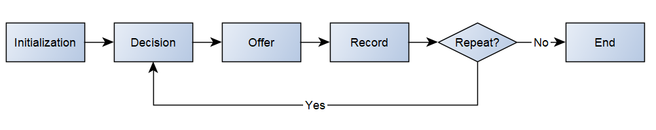

*Figure 1 – Abstract Market Cycle*

## Food Market

Food is an important market in the model because it is the only good or service that does not generate more wealth after it is bought. Agents buy food to live, meaning there is no upper bound on a buying agent’s food price except for their cash. In the food market, agents can only sell or buy food. The initialization phase occurs by checking the amount of food an agent owns. If an agent has extra food, they become a seller. Otherwise, agents will be buyers. During the decision phase, bids in this market are determined by an agent’s hunger, cash, and current food. Buyers will pay more for food if they have more cash available, are closer to starvation, and have little current food. Asks are calculated with an agent’s current food and the cost to produce that food. The average cost of food helps determine the minimum price a seller will accept. As a seller’s total amount of food raises, their asking price per unit of food drops. Ask and bid prices are also influenced by how offers are accepted or rejected. If a seller accepts 5 bids in a row, they will raise their ask. If a seller rejects 5 bids in a row, they will lower their ask. When a buyer is accepted 5 deals in a row, they lower their bid. When a buyer is rejected 5 deals in a row, they raise their bid. During the offer phase buyers randomly send bids over to sellers. When a bid is higher than an ask, the two agents meet in the middle and make a deal. The record phase marks all successful transactions and saves the price both agents agreed on. This process loops for a set number of times each day. Figure 2 below 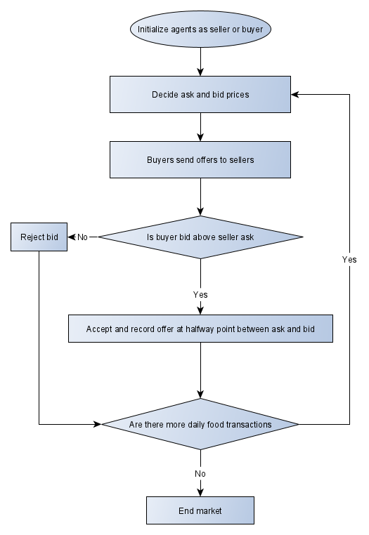follows this process in a flow chart.

*Figure 2 – Food Market General Flow Chart*

## Capital Market

The capital market is the focus of the entire simulation. Since the work of Rognlie (2016) showed how breaking down capital into categories can reveal insights into capital accumulation and wealth concentration, the market in this model allows for two types of capital to be traded. Agents can buy land, which does not depreciate overtime, or machinery, which faces depreciation. As the depreciation rate for machinery is varied, the effects on both types of capital can be measured. In the initialization phase of this market agents can be buyers, or both buyers and sellers. All agents in this market will be buyers, while those with either form of capital will be sellers as well. During the decision phase, bids are affected by an agent’s cash and the possible profits of acquiring the capital. A buyer’s bid will raise with their cash and possible profits. Asks are determined in the same way, but if a seller receives many bids for a capital good their ask may raise. Some variance is introduced to the bids and asks by adding an optimism multiplier effected by how the price of the output good made with that capital is moving relative to its inputs. The offer phase runs next as bids are randomly sent over to sellers. Like the food markets, successful transactions take place at the average of the two price points. The record phase saves these transactions to be viewed later. A visual representation of this process is shown in Figure 3 below.

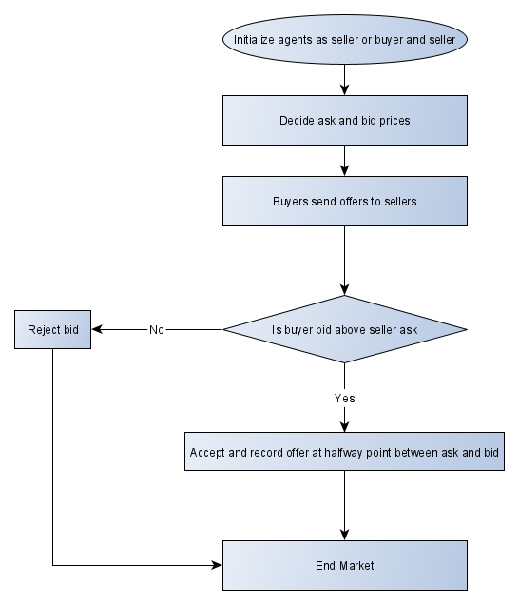*Figure 3 – Capital Market General Flow Chart*

## Labor Market

The labor market is an important aspect of the model because it allows cash to organically flow through the simulation. Since not all agents can own capital and produce food or machinery, some must work and receive income to survive. Like the capital market, two different services can be purchased in the labor market. Agents can work to produce machines or food. As agents work, they gain skill in producing food or machinery. Total skill can also be increased if an adult agent brings their offspring to work. The market’s initialization results in agents being buyers or sellers. Those with both types of capital goods become buyers while agents missing at least one type of capital good are sellers. During the first decision phase in the market, buyers start their bid very low. Buyers use this bid price, their current capital, and the Cobb Douglas function to find the optimal amount of labor needed. The optimal amount of labor is the total skill a buyer is looking for. A buyer’s bid is pushed up or down overtime based on the number of agents willing to take the job. If a buyer’s bids attract more skill than needed, the buyer will lower their bids next time they look for labor. When a buyer attracts less skill than needed, they will raise their bids and look again. A seller’s ask is determined by the cost to feed themselves, the number of sellers hired, and past jobs. A seller’s initial ask will be slightly higher than the last wage they were paid. This ask can decrease if other sellers keep getting hired at a lower wage. To stay competitive, a seller may gradually drop their ask until it reaches the minimum cost needed to feed themselves. During the offer phase all bids are sent to all sellers in the market. Sellers view these bids in a random order. They accept the first bid higher than their ask. Even though a seller may have more skill in machinery production than food harvesting, a seller will take a food harvesting job if it pays higher than their ask. Since it becomes unprofitable for buyers to purchase over a certain amount of skill, a seller may be paid for a portion of his skill because the employer does not need the rest. A seller would only agree to this if the total wage for that portion of skill exceeds the asking price of their total skill amount. The process of adjusting bids and asks and sending offers continues until all labor is purchased or it is no longer profitable for buyers to purchase more labor. All successful transactions in this market occur at the bid price sent by the buyer. The record phase of this market saves the total amount of skill purchased and the cost of that skill. Figure 4 below shows this process within a flow chart.

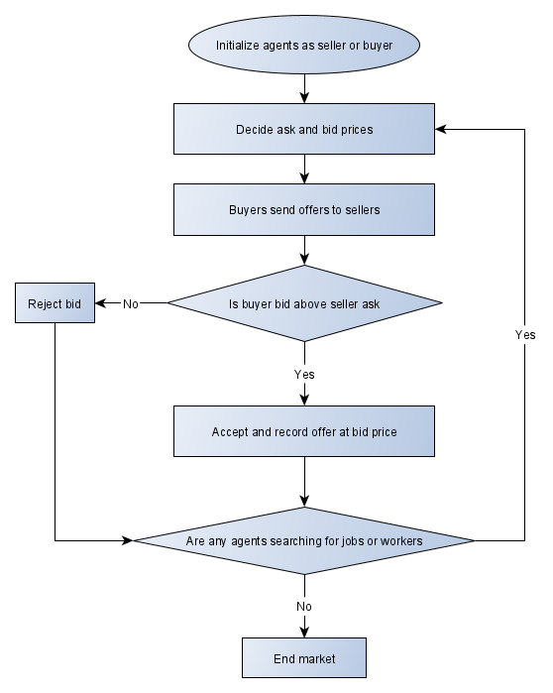*Figure 4 – Labor Market General Flow Chart*

# Results

This section begins by looking at the top decile’s ownership of wealth across all depreciation rates. After, the capital stock is examined to understand how depreciation affected the aggregate value of each capital good. Next, the ownership concentration of land and machinery are measured to narrow down the cause of wealth concentration in the model. Finally, the overall machinery market is inspected, because the relationship between machinery ownership and depreciation was much stronger than the relationship between land ownership and depreciation.

## Result 1

Wealth concentration among the top decile increased with depreciation rate of machinery. General wealth concentration was measured by recording the net worth of each agent every round. Net worth is calculated by adding together the value of an agent’s food, land, machinery, and cash. The value of food, land, and machinery were determined by the median transaction price from the last time the market ran. Figure 5 displays the percentage of wealth owned by the top decile across each simulation. The Y axis displays the percent of wealth owned. The X axis represents the round recorded. Each dot represents the total portion of wealth owned by the top decile of the simulation. The line represents the median portion of wealth owned by the top decile. The median wealth owned by the top decile increased from 84% to almost 97%. The shape of the graphs is a result of the markets for machinery and land not running daily. Since the price of these capital goods is evaluated after the market settles, running the market causes the biggest swing in the value of agents’ portfolios. Otherwise, minor transactions are occurring to move wealth which causes the dots to break away from the rest of the graph every so often. Therefore, there are stretches of dots in a row with some scattered. Each increase in the depreciation rate also caused an increase in median wealth concentration. The result was the opposite of what I excepted. Various economists have shown depreciation decreases overall capital concentration (Piketty 2015; Rognlie 2016). This decrease in capital concentration could lead to a decrease in wealth concentration. Because Rognlie (2016) showed how capital facing little depreciation can grow its share of the capital stock overtime, I analyzed the capital stock next.

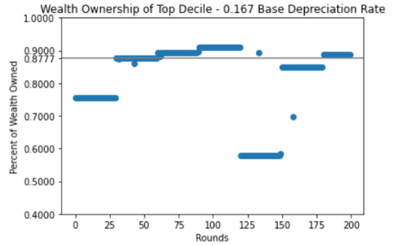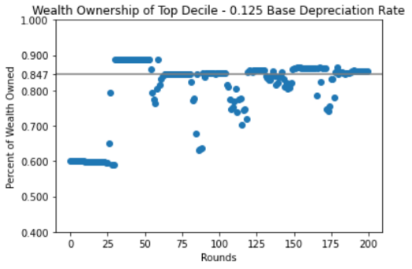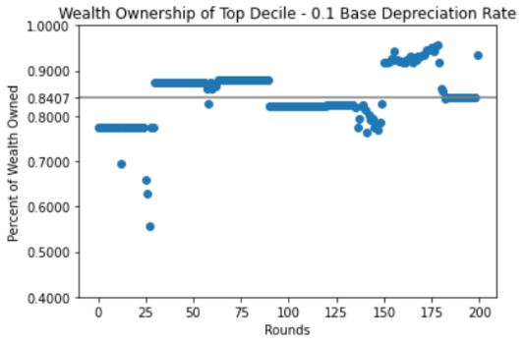

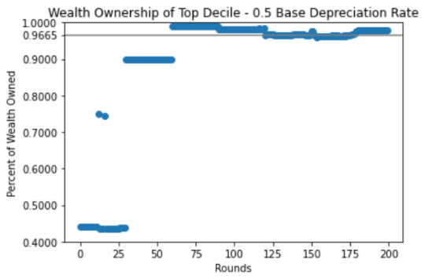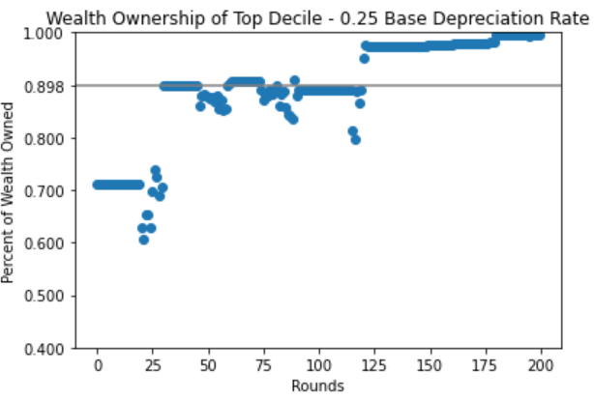

*Figure 5 – Wealth Ownership of Top Decile Across Each Depreciation Rate: The gray line represents median wealth owned by the top decile. As base depreciation raises, the median wealth ownership in the top decile increases.*

## Result 2

The share of capital stock owned by land and machinery did not change significantly because of changing the depreciation rate. Viewing the trends in capital stock across all simulations also gave different results than expected. Instead of seeing machinery’s share of the capital stock drop as depreciation increased, the capital share of machinery and land stayed consistent. Throughout every simulation machinery claimed over 80% of the total capital value. A higher depreciation rate did not erode this high portion of capital value. Figure 6 displays the portion of capital stock claimed by machinery and land. The Y axis shows the portion of total capital stock while the X axis shows the round. Machinery is represented by the black and land is represented by gray. Machinery most likely dominated the capital stock because solving for K in the producer’s Cobb Douglas equation was a function of the producer’s land and machinery. Since machinery was weighted higher in this equation, it became a more valuable asset. Depreciation’s lack of direct effect on capital stock, led me to the conclusion depreciation was not directly affecting capital accumulation through increased cost of maintaining capital within the simulation. Since depreciation had some indirect effect on capital accumulation, I looked deeper into the concentration of machinery and land.

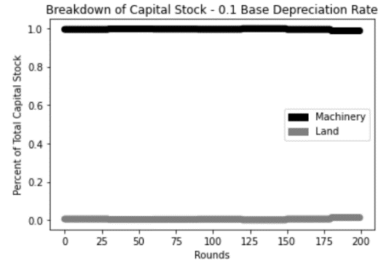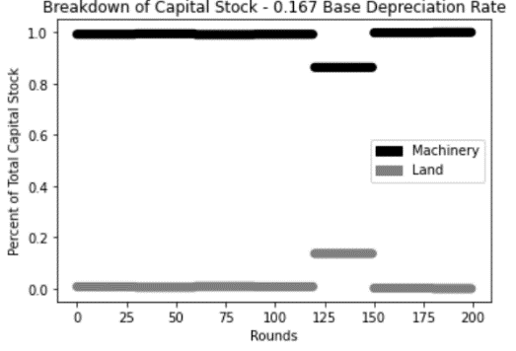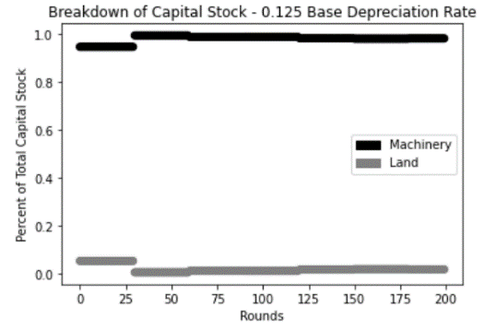

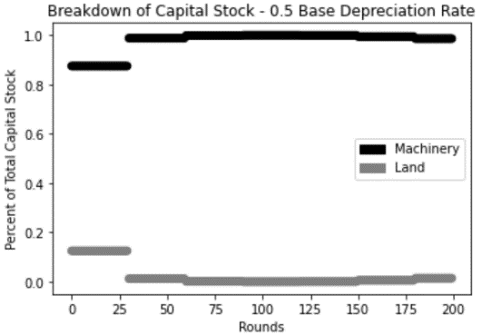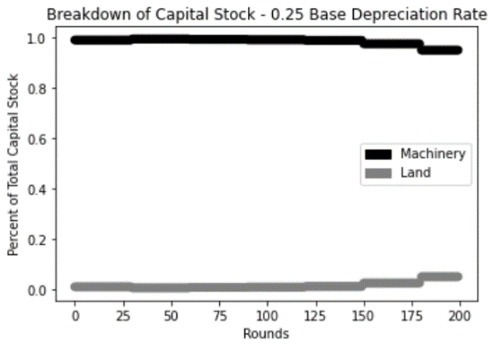

*Figure 6 – Land and Machinery’s Portion of Capital Stock Across Each Depreciation Rate: While the portion of machinery’s capital stock changes slightly across depreciation rates, it always takes up at least 80% of the current capital stock. This shows how depreciation rates had little impact on the overall relative value of land and machinery.*

## Result 3

Land ownership concentration among the top decile had no correlation with depreciation rate. The top decile’s share of land ownership had no correlation with the depreciation rate. I examined the accumulation of land to see if depreciation had a clear effect on it. Figure 7 is very similar to figure 5. The Y axis represents the portion of land owned while the X axis represents the round recorded. Each dot is the top decile’s total portion of land ownership. The line shows the median in each simulation. Instead of moving consistently up or down with depreciation, it moves in both directions. In the two simulations with depreciation rates of 10% and 12.5%, median land ownership of the top decile was around 50%. As depreciation raised to the 3rd highest level (16.7%), the median land ownership dropped to around 44%. The rate of land ownership in the top decile increased to 53% as depreciation rose to 25%. Finally, the percent of machine ownership in the top decile dropped to 35% as the depreciation rose to 50%. The lack of depreciation’s direct effect on land accumulation supports the idea that depreciation played little direct role in capital accumulation. Once again, this was contradictory to the work of Rognlie (2016) and Piketty (2015) who claim high depreciation should offset some capital accumulation. Since depreciation seemed to have little correlation with land ownership, I wanted to observe machine ownership to better understand the market depreciation directly impacts. I then examined machine ownership to better understand this effect.

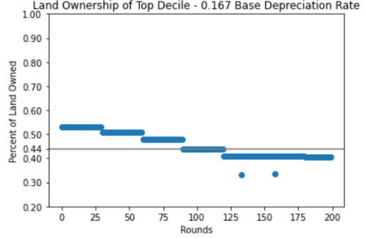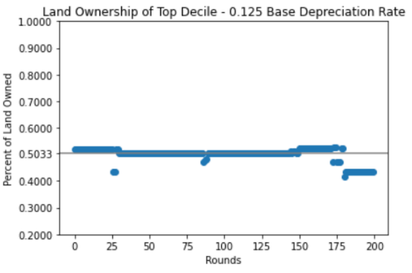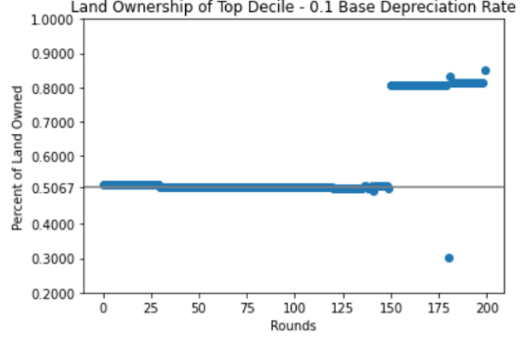

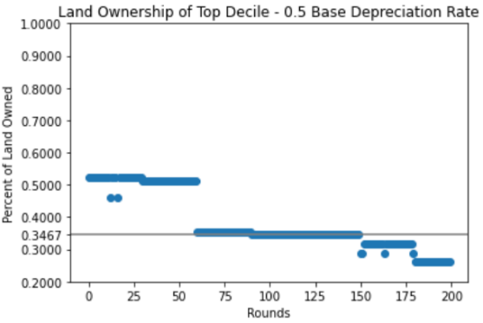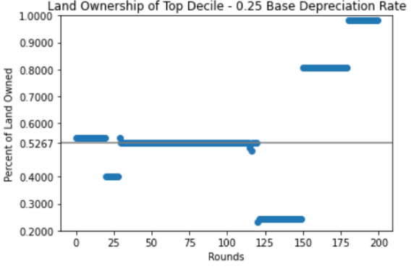

*Figure 7 – Land Ownership of Top Decile Across Each Depreciation Rate: The gray line shows the median land ownership for each depreciation rate. The median moves up and down as depreciation raises signifying a weak relationship between the two factors.*

## Result 4

Machine ownership concentration among the top decile increased with depreciation rate. The top decile’s share of machine ownership revealed the concentration of machine ownership increasing with the base depreciation rate. Figure 8, which is like figures 5 and 7, shows the portion of machine ownership in the top decile across all simulations. The Y axis shows the portion of machines owned while the X axis shows which round is being recorded. The line once again shows the median portion of machines owned by the top decile. The trend in median machine ownership is like wealth concentration. The machine ownership concentration steadily increased with depreciation. 81% of machines are owned by the top decile when depreciation is at its lowest. This number climbs up to over 97% in the simulation with the highest depreciation. The direct link between depreciation and machine ownership concentration is key in understanding why the results of this simulation differ from the effect of depreciation outlined in other papers (Piketty 2015; Rognlie 2016). The positive relationship between machine ownership concentration and depreciation rate further supports the idea that costs associated with higher depreciation did not deter wealth concentration in this simulation. To understand how depreciation was affecting the machine market the distribution of machines and their quality tiers were analyzed in the next result.

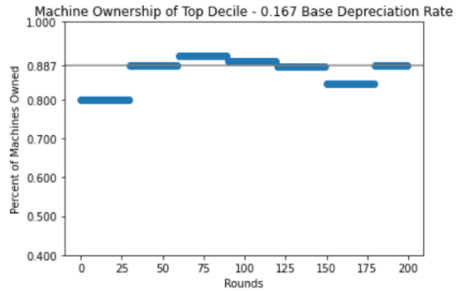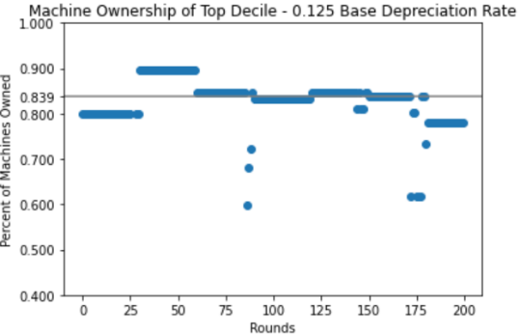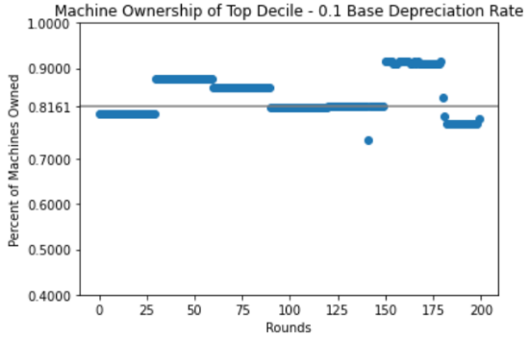

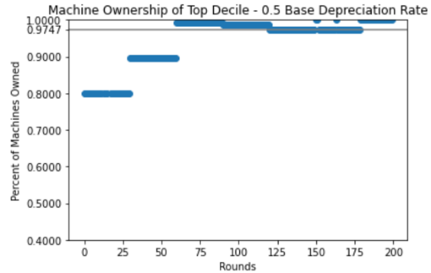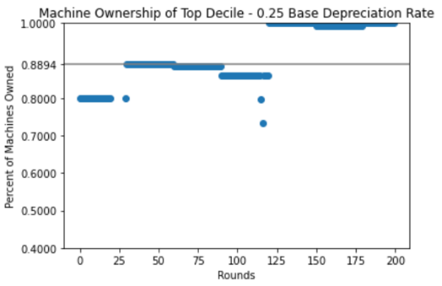

*Figure 8 – Machine Ownership of Top Decile Across Each Depreciation Rate: The gray line shows the median machine ownership for each depreciation rate. As the base depreciation raises, the concentration of machine ownership does as well.*

## Result 5

The portion of used machines decreased as depreciation increased. By analyzing the machine quality distribution, I found the portion of used machines in the machine market fell as depreciation rose. As machines depreciate, they can move between one of four qualities. Since a lower quality machine will expire sooner, it is valued less. Figure 8 shows this distribution across simulations. The Y axis shows the total number of useful machines circulating in the simulation while the X axis shows the round this number was recorded. Each color represents a different machine quality. Black represents the newest machines while each shade lighter represents a more used machine. Across the two simulations with the lowest depreciation, the market for used machines is active with a moderate portion of brand-new machines. As the depreciation rate increases to 16.7%, the portion of new machines begins to balloon. The two simulations run at the highest levels of depreciation show a very weak used machine market. The simulation run at 25% depreciation shows the used market completely disappearing after round 120. The simulation with the highest depreciation is almost completely occupied by new machines. Since new machines became more prevalent in simulations with a high depreciation rate, agents without a lot of cash were cut out of the market. Only the wealthiest agents could afford the new machines. Since unwealthy agents were priced out of the market, wealthy agents accumulated most of the machines. As the simulation progressed, only those who could afford the high upfront price of machinery were able to reap the benefits of capital. In this simulation, being a producer was key to becoming wealthy. High prices on machinery raised the barrier to entry and kept many out of the market. Higher rates of depreciation resulted in higher barriers of entry. The higher barriers of entry caused wealth concentration to increase. This explains why the depreciation rate and 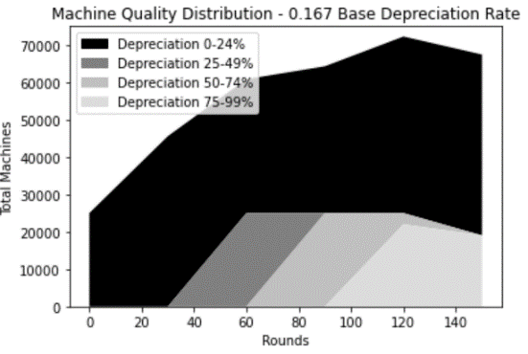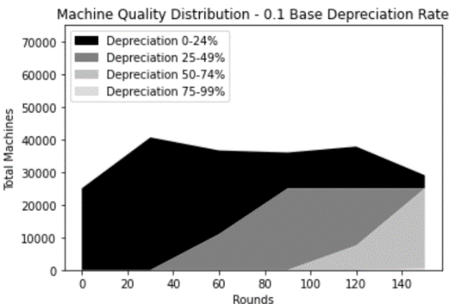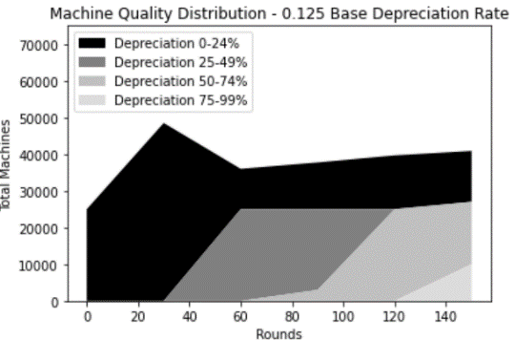level of wealth concentration have a positive correlation.

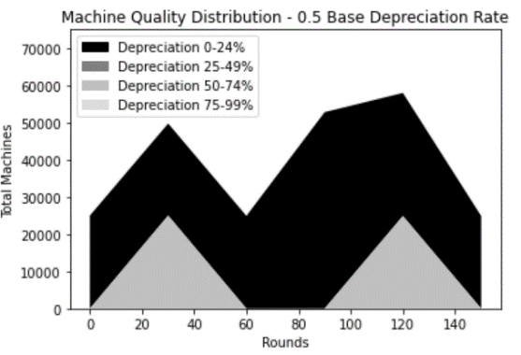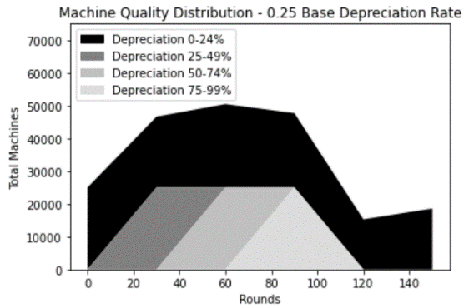

*Figure 9 – Machine Total and Quality Distribution Across Each Depreciation Rate: As the depreciation rate raises, the portion of new machines in the simulation increases due to older machines depreciating faster. In simulations with 25% and 50% depreciation only new machines are available for entire periods outside of the first few rounds.*

# Discussion

While multiple economists have commented on depreciation’s ability to reign in capital accumulation (Alvaredo et al. 2009; Piketty 2015; Rognlie 2016), this study offers a different perspective on how depreciation effects wealth concentration and capital accumulation. Instead of focusing on the long run effects associated with upkeeping and maintaining technology, a short-term model showed how the secondhand capital market breaks down high barriers of entry. By having access to cheaper more used machines, unwealthy agents were able to afford capital for themselves. This offset some of the capital accumulation in the top decile. These results hold important implications for those who regulate intellectual property. If a patent were to expire closer to the last useful date of a technology, only those who can afford the various costs associated with obtaining the technology will be able to generate value with it. This conclusion is consistent with the work of Iwaisako and Futagami (2011). Their work found a longer patent window makes it more difficult for people to accumulate capital. This was a result of higher costs to accumulate capital. Even though a longer patent window is associated with a low depreciation rate, one must consider how depreciation is applied in my model. Depreciating a machine makes it completely useless, as if the innovation were obsolete. If one were to liken new machines in my simulation to ones protected by a patent, and secondhand machines to unlicensed technology, the connection becomes clear. In simulations with a low depreciation rate, machines are still useful once they are no longer brand new (patent protected). This lowers the cost of capital accumulation. In simulations with high depreciation rates, new (patent protected) machinery made up most of the machines in the market and raised the cost of capital accumulation. The time between a machine being unlicensed, but not obsolete shrank as depreciation increased. Since the study of Iwaisako and Futagami (2011) did not change depreciation with patent laws, longer patents resulted in a shorter window for the unlicensed capital to be useful. This is the equivalent to a company releasing their software for public use after it has been deprecated. A real-world example of this is present in the open-source software community. Open-source software has publicly viewable code making it usually free to use and easy for businesses or consumers to change on their own. This allows businesses and consumers to use new technology at a low price before it has been deprecated. A case study was conducted in India to see the economic impact open-source software has in the private and public sector (De 2009). The work shows cost savings across the board. Some school districts saved over $10 million on IT costs. The private sector also saw a reduction in IT costs as two insurance firms were able to save over $20 million combined (De 2009). The research also shows how the cost savings over time will grow as information technology becomes more prevalent in the economy. The lack of intellectual protections around open-source software allows for cost reductions that give developing countries like India the opportunity to compete on a global scale in technology. Restricting the usage and applying patent laws to this currently free software would drive up the cost of using this technology infrastructure and limit those who could access it. Lack of access to information technology will only strengthen the digital divide in developing countries. A more pronounced digital divide could result in higher prices, less informed healthcare decisions and lack of educational opportunity (Lu 2001). Opening access to capital for all could help bridge these gaps.

# Conclusion

In my results, I found raising the base depreciation rate of machinery caused an increase in wealth concentration. In simulations with the lowest depreciation, the median wealth owned by the top decile was around 84%. In the simulation with the highest depreciation, this number increased to almost 97%. Before diving more into capital accumulation, I observed the capital stock. I wanted to see if increased rates of depreciation caused machinery to take a lower share of the capital stock. Result 2 shows how depreciation had little effect on land or machine’s share of capital stock. I then explored the concentration of land and machine ownership. Result 3 shows little correlation between depreciation rate and land ownership concentration. Result 4 reveals a positive correlation between the base depreciation rate and concentration of machine ownership. To better understand why the accumulation of machinery was occurring, I analyzed the machinery market by looking at the distribution of machine qualities. Once I saw the breakdown of new and used machines in the simulation, I found the used machine market contributed to a smaller portion of the total machine market as depreciation increased. This resulted in no cheap used machinery being available for lower class agents to purchase. Result 5 contains these graphs and demonstrates how machine quality distribution plays a role in wealth concentration.

Most research presents more questions than answers. Because the model has many different aspects of each market, multiple routes can be taken to keep exploring this topic. While this paper shows the results of the model from relatively short simulations (200 rounds), other studies have looked at multigenerational wealth and the money transfers between each generation (Kopczuk and Kreiner 2017). Even though the current model is capable for running for tens of thousands of rounds, this would take an extremely long time. Any slight problem in the model would require it to be rerun taking up even more time. Unfortunately, the model’s slow speed is a result of how derivates are calculated. If this process were sped up, the model could help answer questions on multigenerational wealth ownership. Since the lack of cheap machinery caused high levels of accumulation in the wealthiest decile, a rental system for machinery could present interesting findings. While a rental market could help unwealthy agents earn some money with their savings, the work of Piketty (2015) suggests this will do little to alleviate wealth concentration unless the economy’s growth is higher than the rental rates for capital. Another method to offset the concentration of machinery could be to subsidize capital accumulation. No government was present in this simulation and as a result no redistributive or tax policies were tested. Adding a progressive tax that subsidizes capital purchasing in unwealthy agents could significantly reduce wealth concentration in the simulation (Boucekkine et al. 2004; Saez and Zucman 2014).

Even though it can be hard to build bridges between the model and reality, agent-based models allow for new perspectives through an economic lens (Impullitti and Rebmann 2002). When I initially created the model, the secondhand market for machinery was not added with the intent of it having a large effect on capital accumulation. By creating three interconnected markets following neoclassical assumptions, market pricing and agent possession data could be paired together for a very detailed analysis of the model. Combining the market pricing and agent possession data allowed me to explore the capital markets in great depth after the initial discovery that wealth concentration increased with the depreciation rate. Understanding that this relationship was a result of used machines becoming obsolete too quickly, carries interesting implications. One of the most important being regulators need to understand the full technological landscape, especially different technologies that resolve similar problems, to make effective patent regulations. If competing products or innovations on the horizon deprecate a technology before its patent has expired, many people will miss out on creating value with the now deprecated innovation. The lack of real-world inconsistencies within agent-based models allows for previously unconsidered perspectives to manifest themselves (Koesrindartoto 2014). Agent-based modeling is a useful tool for any economist looking to better understand the dynamics within markets.

# References

Alvaredo, Facundo, and Saez. “Income and Wealth Concentration in Spain from a Historical and Fiscal Perspective.” *Journal of the European Economic Association*, vol. 7, no. 5, 2009, pp. 1140–1167., doi:10.1162/jeea.2009.7.5.1140.

Angle, John. “The Surplus Theory of Social Stratification and the Size Distribution of Personal Wealth.” *Social Forces*, vol. 65, no. 2, 1986, p. 293., doi:10.2307/2578675.

Boghosian and Li, Jie. “Duality in an Asset Exchange Model for Wealth Distribution.” *Physica A: Statistical Mechanics and Its Applications*, vol. 497, 2018, pp. 154–165., doi:10.1016/j.physa.2017.12.068.

Boghosian, Li, C. and Li, J. “The Affine Wealth Model: An Agent-Based Model of Asset Exchange that Allows for Negative-Wealth Agents and its Empirical Validation.” *Physica A: Statistical Mechanics and Its Applications*, vol. 516, 2019, pp. 423–442., doi:10.1016/j.physa.2018.10.042.

Boucekkine, Licandro, and Rio. “Obsolescence and Modernization in the Growth Process.” *Journal of Development Economics*, vol. 77, no. 1, 2005, pp. 153–171., doi:10.1016/j.jdeveco.2004.03.004.

Chakraborti, Anirban. “Distributions of Money in Model Markets Of Economy.” *International Journal of Modern Physics C*, vol. 13, no. 10, 2002, pp. 1315–1321., doi:10.1142/s0129183102003905.

Damaceanu and Romulus-Catalin. “An Agent-Based Computational Study of Wealth Distribution in Function of Resource Growth Interval Using NetLogo.” *Applied Mathematics and Computation*, vol. 201, no. 1-2, 2008, pp. 371–377., doi:10.1016/j.amc.2007.12.042.

De, Rahul. “Economic Impact of Free Open-Source Software – A Study in India.” *Indian Institute of Management Banglalore*, 2009, www.iimb.ac.in/sites/default/files/inline-files/Rahul-De-Economic-Impact-on-Free-and-Open-Source-Software-A-Study-in-India.pdf.

Elliott III, W., & Rauscher, E. The Effect of Wealth Inequality on Higher Education Outcomes: A Critical Review. *Sociology Mind,* *04*(04), 2014, 282-297. doi:10.4236/sm.2014.44029

Glaeser, Edward L., Gyourko, Joseph, and Saks, Raven. “Why is Manhattan so Expensive? Regulation and the Rise in Housing Prices.” *The Journal of Law and Economics*, vol. 48, no. 2, 2005, pp. 331–369., doi:10.1086/429979.

Gode, Dhananjay K., and Shyam Sunder. “Allocative Efficiency of Markets with Zero-Intelligence Traders: Market as a Partial Substitute for Individual Rationality.” *Journal of Political Economy*, vol. 101, no. 1, 1993, pp. 119–137., doi:10.1086/261868.

Hailu, Atakelty, and Steven Schilizzi. “Learning in a ‘Basket of Crabs’: An Agent-Based Computational Model of Repeated Conservation Auctions.” *Lecture Notes in Economics and Mathematical Systems*, 2005, pp. 27–39., doi:10.1007/3-540-27296-8_3.

Impullitti, Giammario, and Matthias Rebmann. “An Agent-Based Model of Wealth Distribution.” *Schwartz Center for Economic Policy Analysis (SCEPA)*, 26 Sept. 2002.

Ispolatov, S., Krapivsky, P.L., and Redner, S. “Wealth Distributions in Asset Exchange Models.” *The European Physical Journal B*, vol. 2, no. 2, 1998, pp. 267–276., doi:10.1007/s100510050249.

Iwaisako, Tatsuro, and Koichi Futagami. “Patent Protection, Capital Accumulation, and Economic Growth.” *Economic Theory*, vol. 52, no. 2, 2011, pp. 631–668., doi:10.1007/s00199-011-0658-y.

Karabarbounis, Loukas, and Brent Neiman. “The Global Decline of the Labor Share.” 2013, doi:10.3386/w19136.

Kelly, Morgan. “Inequality and Crime.” *Review of Economics and Statistics*, vol. 82, no. 4, 2000, pp. 530–539., doi:10.1162/003465300559028.

Koesrindartoto, Deddy. “Treasury Auctions, Uniform or Discriminatory?: An Agent-Based Approach.” *Research Gate*, 2004.

Lu, Ming-te. “Digital Divide in Developing Countries.” *Journal of Global Information Technology Management*, vol. 4, no. 3, 2001, pp. 1–4., doi:10.1080/1097198x.2001.10856304.

Mayer, Susan E., and Ankur Sarin. “Some Mechanisms Linking Economic Inequality and Infant Mortality.” *Social Science & Medicine*, vol. 60, no. 3, 2005, pp. 439–455., doi:10.1016/j.socscimed.2004.06.005.

Piketty, Thomas. “About Capital in the Twenty-First Century.” *American Economic Review*, vol. 105, no. 5, 2015, pp. 48–53., doi:10.1257/aer.p20151060.

Prados de la Escosura, L. “Inequality, Poverty and the Kuznets Curve in Spain, 1850-2000.” *European Review of Economic History*, vol. 12, no. 3, 2008, pp. 287–324., doi:10.1017/s1361491608002311.

Rognlie, Matthew. “Deciphering the Fall and Rise in the Net Capital Share: Accumulation or Scarcity?” *Brookings Papers on Economic Activity*, vol. 2015, no. 1, 2016, pp. 1–69., doi:10.1353/eca.2016.0002.

Saez, Emmanuel, and Gabriel Zucman. “Wealth Inequality in the United States since 1913: Evidence from Capitalized Income Tax Data.” 2014, doi:10.3386/w20625.

Stiglitz, J. E. “Distribution of Income and Wealth Among Individuals.” *Econometrica*, vol. 37, no. 3, 1969, p. 382., doi:10.2307/1912788.

1. AbcEconomics is a python-based library for a technical look at the model refer to the project https://github.com/aeghian/Wealth_Concentration_ABM
2. These numbers were picked because depreciation was applied to machines over a certain number of cycles. The machine would expire with no use after a different number of cycles in each simulation. The number of cycles picked in each simulation were 10, 8, 6, 4, and 2 resulting in the percentages 10, 12.5, 16.7, 25, and 50.
3. Food production included a multiplier of 100 and machine production included a multiplier of 10. This helped scale production so one piece of food was not produced at the rate of one machine.